after you open the project please modify properties config

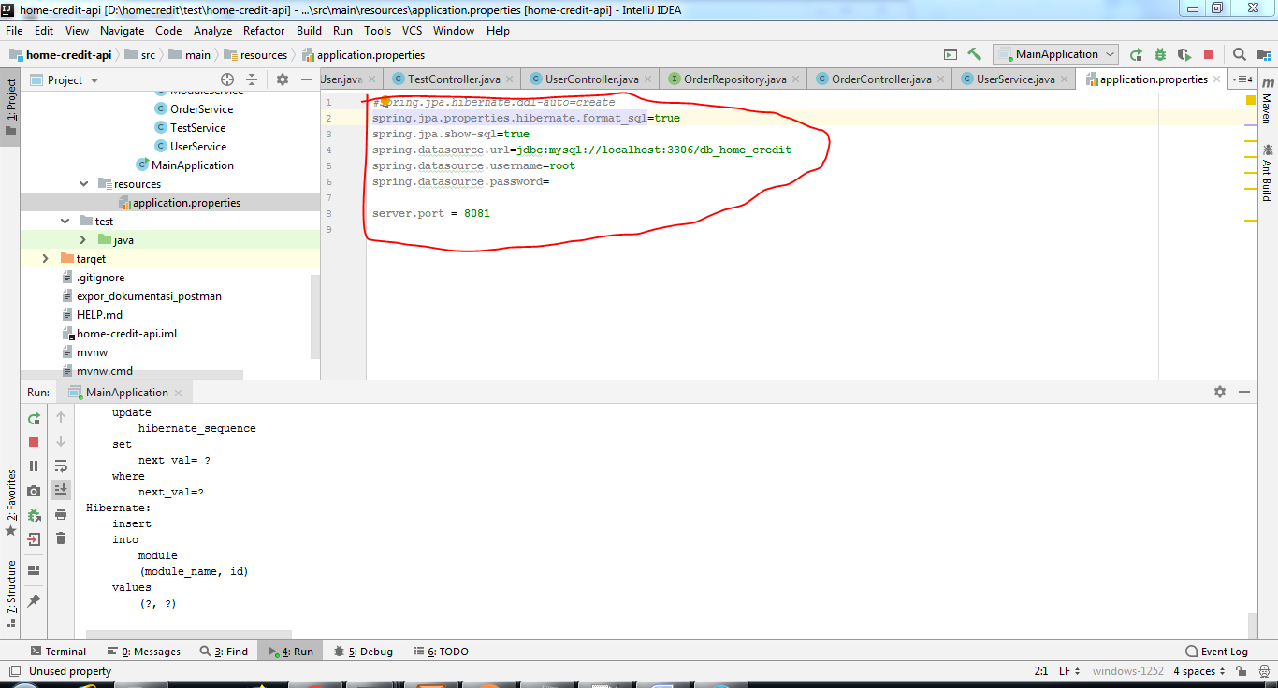

Api doc

1.http://localhost:8081/api/module/add

header :

(Content-Type:application/json)

Body(json):

{

"moduleName":"PromoCard",

"moduleOrder":1

}

response:

--jika sukses

header

(HTTP status : 200)

(**Message :**Succes create data)

Body(json):

{

"data": {

"id": 2,

"moduleName": "CategoryCard",

"moduleOrder": 2

},

"message": "Succes create data"

}

--jika Duplicate moduleName

header

(HTTP status : 304)

(**Message :** Module Name is duplicate)

Body(json):

2.http://localhost:8081/api/user/add

header :

(Content-Type:application/json)

Body(json):

{

"userName":"UserA"

}

response:

--jika sukses

header

(HTTP status : 200)

(**Message :**Succes create data)

Body(json):

{

"data": {

"id": 6,

"username": "UserA"

},

"message": "Succes create data"

}

--jika Duplicate moduleName

header

(HTTP status : 304)

(**Message :** Username is duplicate)

Body(json):

3. http://localhost:8081/api/order/add

header :

(Content-Type:application/json)

Body(json):

{

"moduleName":"PromoCard",

"userName":"UserA"

}

response:

--jika sukses

header

(HTTP status : 200)

(**Message :**Succes create data)

Body(json):

{

"data": {

"id": 11,

"module": {

"id": 1,

"moduleName": "PromoCard",

"moduleOrder": 1

},

"user": {

"id": 6,

"username": "UserA"

}

},

"message": "Succes create data"

}

--jika moduleName atau user tidak terdaftar

header

(HTTP status : 304)

(**Message :** User Not Found/ Module Not Found)

Body(json):

4. http://localhost:8081/api/user/getByName

header :

Body(form-data):

UserName = "UserB"

response:

--jika sukses

header

(HTTP status : 200)

(**Message :** Succes get data)

Body(json):

{

"data": [

{

"id": 6, (note=digunakan untuk proses untuk frontend)

"username": "UserA"

}

],

"message": "Succes get data"

}

--jika Username tidak terdaftar

header

(HTTP status : 304)

(**Message :** Data not found)

Body(json):

5. http://localhost:8081/api/order/getByUserId

header :

Body(form-data):

UserID= 6

response:

--jika sukses

header

(HTTP status : 200)

(**Message :** Succes get data)

Body(json):

{

"modules": [

{

"moduleName": "PromoCard",

"moduleOrder": 1

},

{

"moduleName": "CategoryCard",

"moduleOrder": 2

},

{

"moduleName": "FlashSaleCard",

"moduleOrder": 3

},

{

"moduleName": "HistoryCard",

"moduleOrder": 4

},

{

"moduleName": "NewsCard",

"moduleOrder": 5

}

]

}

6. http://localhost:8081/api/order/getByUserName

header :

Body(form-data):

userName="UserA"

response:

--jika sukses

header

(HTTP status : 200)

(**Message :** Succes get data)

Body(json):

{

"modules": [

{

"moduleName": "PromoCard",

"moduleOrder": 1

},

{

"moduleName": "CategoryCard",

"moduleOrder": 2

},

{

"moduleName": "FlashSaleCard",

"moduleOrder": 3

},

{

"moduleName": "HistoryCard",

"moduleOrder": 4

},

{

"moduleName": "NewsCard",

"moduleOrder": 5

}

]

}